

# 

### Semester Two Examination, 2018

### Question/Answer booklet

# MATHEMATICS

**SOLUTIONS**

**SPECIALIST**

**UNITS 1 AND 2**

## Section One:

## Calculator-free

|  |  |  |  |  |  |  |  |  |  |  |
| --- | --- | --- | --- | --- | --- | --- | --- | --- | --- | --- |
| Student number: In figures |  |  |  |  |  |  |  |  |  |  |

In words

Your name

## Time allowed for this section

Reading time before commencing work: five minutes

Working time: fifty minutes

## Materials required/recommended for this section

***To be provided by the supervisor***

This Question/Answer booklet

Formula sheet

***To be provided by the candidate***

Standard items: pens (blue/black preferred), pencils (including coloured), sharpener,  
correction fluid/tape, eraser, ruler, highlighters

Special items: nil

## Important note to candidates

No other items may be taken into the examination room. It is **your** responsibility to ensure that you do not have any unauthorised material. If you have any unauthorised material with you, hand it to the supervisor **before** reading any further.

## Structure of this paper

|  |  |  |  |  |  |
| --- | --- | --- | --- | --- | --- |
| Section | Number of questions available | Number of questions to be answered | Working  time (minutes) | Marks available | Percentage of examination |
| Section One:  Calculator-free | 8 | 8 | 50 | 52 | 35 |
| Section Two:  Calculator-assumed | 13 | 13 | 100 | 98 | 65 |
|  | | |  | **Total** | 100 |

## Instructions to candidates

1. The rules for the conduct of examinations are detailed in the school handbook. Sitting this examination implies that you agree to abide by these rules.

2. Write your answers in this Question/Answer booklet.

3. You must be careful to confine your response to the specific question asked and to follow any instructions that are specified to a particular question.

4. Supplementary pages for the use of planning/continuing your answer to a question  
have been provided at the end of this Question/Answer booklet. If you use these pages to continue an answer, indicate at the original answer where the answer is continued, i.e. give the page number.

5. Show all your working clearly. Your working should be in sufficient detail to allow your answers to be checked readily and for marks to be awarded for reasoning. Incorrect answers given without supporting reasoning cannot be allocated any marks. For any question or part question worth more than two marks, valid working or justification is required to receive full marks. If you repeat any question, ensure that you cancel the answer you do not wish to have marked.

6. It is recommended that you do not use pencil, except in diagrams.

7. The Formula sheet is not to be handed in with your Question/Answer booklet.

Section One: Calculator-free 35% (52 Marks)

This section has**eight (****8)** questions. Answer **all** questions. Write your answers in the spaces provided.

Working time: 50 minutes.

Question 1 (7 marks)

Let $A=\left[\begin{matrix}2 & -1 \\ -3 & 0\end{matrix}\right]$ and $B=\left[\begin{matrix}5 & 4 \\ 7 & 6\end{matrix}\right]$.

Determine

(a) $AA^{-1}$. (1 mark)

|  |
| --- |
| **Solution** |
| $$AA^{-1}=I=\left[\begin{matrix}1 & 0 \\ 0 & 1\end{matrix}\right]$$ |
| **Specific behaviours** |
| ✓ identity matrix |

(b) $2A+B$. (2 marks)

|  |
| --- |
| **Solution** |
| $$2×\left[\begin{matrix}2 & -1 \\ -3 & 0\end{matrix}\right]+\left[\begin{matrix}5 & 4 \\ 7 & 6\end{matrix}\right]=\left[\begin{matrix}4 & -2 \\ -6 & 0\end{matrix}\right]+\left[\begin{matrix}5 & 4 \\ 7 & 6\end{matrix}\right]=\left[\begin{matrix}9 & 2 \\ 1 & 6\end{matrix}\right]$$ |
| **Specific behaviours** |
| ✓ multiple of $A$ ✓ correct sum |

(c) $AB$. (2 marks)

|  |
| --- |
| **Solution** |
| $$\left[\begin{matrix}2 & -1 \\ -3 & 0\end{matrix}\right]\left[\begin{matrix}5 & 4 \\ 7 & 6\end{matrix}\right]=\left[\begin{matrix}3 & 2 \\ -15 & -12\end{matrix}\right]$$ |
| **Specific behaviours** |
| ✓ at least two correct elements  ✓ correct product |

(d) $B^{-1}$. (2 marks)

|  |
| --- |
| **Solution** |
| $${\left[\begin{matrix}5 & 4 \\ 7 & 6\end{matrix}\right]}^{-1}=\frac{1}{30-28}×\left[\begin{matrix}6 & -4 \\ -7 & 5\end{matrix}\right]=\left[\begin{matrix}3 & -2 \\ -3.5 & 2.5\end{matrix}\right]$$ |
| **Specific behaviours** |
| ✓ indicates determinant  ✓ correct inverse |

Question 2 (4 marks)

$z_{1}$ and $z_{2}$ are the complex solutions to the equation $z^{2}-2z+10=0$.

The location of $z_{1}$ is shown in the complex plane below.

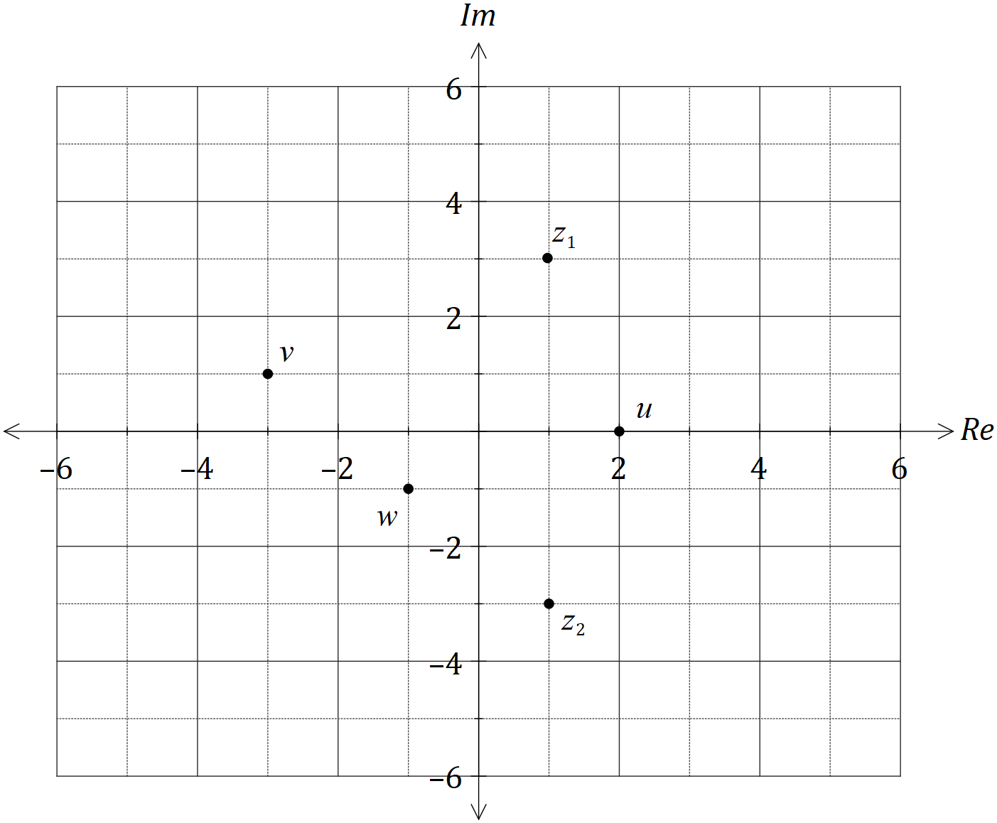

Add, with a label, the following complex numbers to the complex plane above.

|  |
| --- |
| **Solution** |
| $$z_{2}=\overline{z_{1}}=1-3i \\ u=2 \\ v=i\left(1+3i\right)=-3+i \\ w=\overline{-1+i}=-1-i$$ |
| **Specific behaviours** |
| ✓ plots $z_{2}$ ✓ plots $u$ ✓ plots $v$ ✓ plots $w$ |

(a) $z_{2}$. (1 mark)

(b) $u=z_{1}+z_{2}$. (1 mark)

(c) $v=iz_{1}$. (1 mark)

(d) $w=\overline{u+v}$. (1 mark)

Question 3 (6 marks)

(a) Draw a neat diagram to illustrate the angle in the alternate segment theorem. (2 marks)

|  |
| --- |
| **Solution** |
|  |
| **Specific behaviours** |
| ✓ diagram correctly shows circle, tangent and triangle  ✓ clearly marks angles that are equal |

(b) Consider the statement 'if a pentagon is regular, then it has sides of equal length'.

(i) Write the inverse of the statement. (1 mark)

|  |
| --- |
| **Solution** |
| If a pentagon is **not** regular, then it **does not have** sides of equal length. |
| **Specific behaviours** |
| ✓ changes $P⇒Q$ to $\overline{P}⇒\overline{Q}$ |

(ii) Write the contrapositive of the statement. (1 mark)

|  |
| --- |
| **Solution** |
| If a pentagon **does not have** sides of equal length, then it is **not** regular. |
| **Specific behaviours** |
| ✓ changes $P⇒Q$ to $\overline{Q}⇒\overline{P}$ |

(iii) Write the converse of the statement and neatly sketch a counter-example to show that the converse is not true. (2 marks)

|  |
| --- |
| **Solution** |
| If a pentagon has sides of equal length, then it is regular. |
| **Specific behaviours** |
| ✓ reverses $P⇒Q$ to $Q⇒P$ ✓ diagram shows irregular pentagon with equal sides |

Question 4 (8 marks)

(a) On the axes below, sketch the graphs of $y=\tan\left(\begin{matrix}x \\ \overline{2}\end{matrix}\right)$ and $y=\cot\left(\begin{matrix}x \\ \overline{2}\end{matrix}\right)$, where $0≤x≤360°$, labelling all asymptotes. Note that $\tan{76°}≈4$. (5 marks)

|  |
| --- |
| **Solution** |
| See graph |
| **Specific behaviours** |
| ✓ tan graph through  ✓ asymptote for tan graph  ✓ cot graph through $B, C, D$ ✓ two asymptotes for cot graph  ✓ accurately uses $\tan{76°}≈4$ for both  *NB solution assumes cot=cos/sin,* ***not*** *1/tan* |

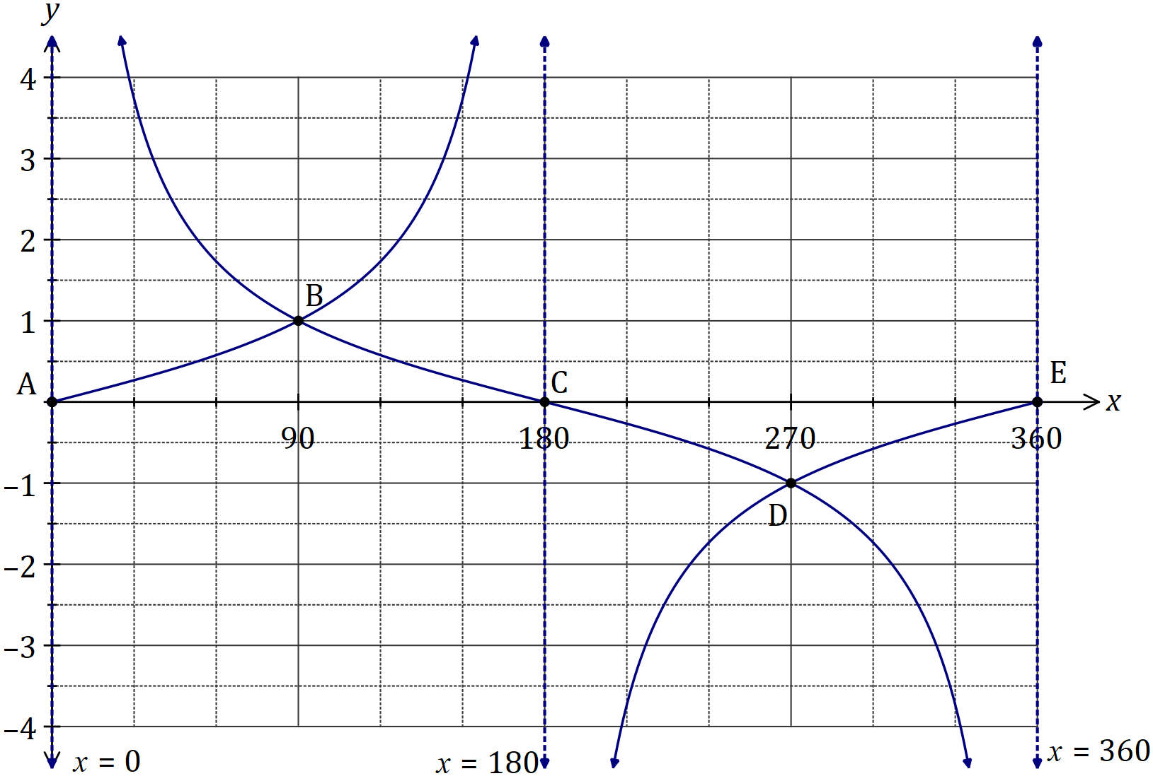

(b) Solve the equation $\sec^{2}{(x)}=3\tan^{2}{(x)}-1$ over the interval $0≤x≤360°$. (3 marks)

|  |
| --- |
| **Solution** |
| $$1+\tan^{2}{(x)}=3\tan^{2}{(x)}-1$$ $$\tan^{2}\left(x\right)=1$$ $$\tan{x}=±1$$ $$x=45°, 135°, 225°, 315°$$ |
| **Specific behaviours** |
| ✓ uses Pythagorean identity  ✓ correct values for $\tan{x}$ ✓ correct solutions |

Question 5 (6 marks)

The position vectors of points $P$ and $Q$ are $p=\left[\begin{matrix}3 \\ 1\end{matrix}\right]$ and $q=\left[\begin{matrix}1 \\ -1\end{matrix}\right]$ respectively.

(a) Determine the magnitude of the displacement vector $\vec{PQ}$. (2 marks)

|  |
| --- |
| **Solution** |
|  |
| **Specific behaviours** |
| ✓ correct $\vec{PQ}$ ✓ correct magnitude |

(b) Determine the values of $λ$ so that $\left|p-λq\right|=4$. (4 marks)

|  |
| --- |
| **Solution** |
| $$p-λq=\left[\begin{matrix}3-λ \\ 1+λ\end{matrix}\right]$$ $$∴{\left(3- λ\right)}^{2}+{\left(1+λ\right)}^{2}=16$$ $$λ^{2}-6λ+9+λ^{2}+2λ+1=16$$ $$2λ^{2}-4λ-6=0$$ $$λ^{2}-2λ-3=0$$ $$\left(λ+1\right)\left(λ-3\right)=0$$ $$λ=-1, λ=3$$ |
| **Specific behaviours** |
| ✓ expression for vector in terms of $λ$ ✓ equation for magnitude of vector  ✓ simplifies and factorises equation  ✓ states both values for $λ$ |

Question 6 (8 marks)

Let $f\left(x\right)=2\sin{x}+2\cos{x}$.

(a) Express $f(x)$ in the form $r\sin\left(x+α\right)$ where $0<α<\frac{π}{2}$. (4 marks)

|  |
| --- |
| **Solution** |
| $$r=\sqrt{2^{2}+2^{2}}=2\sqrt{2}$$ $$\sin\left(x+α\right)=\frac{2}{2\sqrt{2}}\sin{x}+\frac{2}{2\sqrt{2}}\cos{x} \\ =\sin{x}\cos{α}+\cos{x}\sin{α}$$ $$∴\cos{α}=\frac{2}{2\sqrt{2}}=\frac{1}{\sqrt{2}}, \sin{α}=\frac{2}{2\sqrt{2}}=\frac{1}{\sqrt{2}}⇒α=\frac{π}{4}$$ $$f\left(x\right)=2\sqrt{2}\sin\left(x+\frac{π}{4}\right)$$ |
| **Specific behaviours** |
| ✓ value of $r$ ✓ values of $\sin{α}$ and $\cos{α}$ ✓ value of $α$ ✓ expression for $f(x)$ |

(b) Sketch the graph of $y=f(x)$. (4 marks)

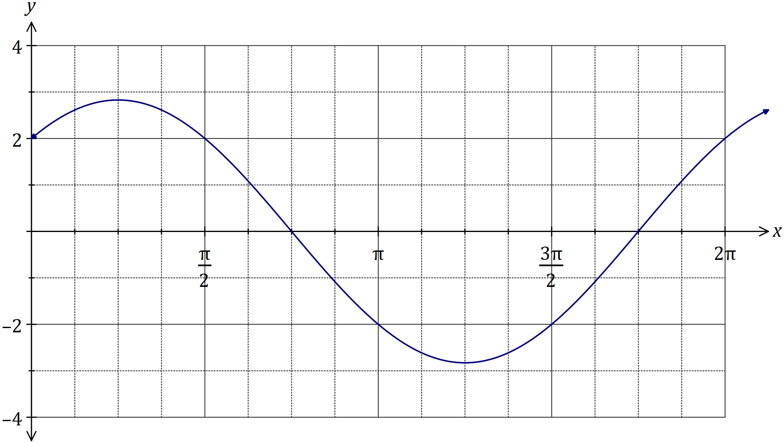

|  |
| --- |
| **Solution** |
| See graph |
| **Specific behaviours** |
| ✓ -intercept  ✓ roots  ✓ maximum and minimum  ✓ smooth sinusoidal curve |

Question 7 (5 marks)

Let $OAPB$ be a parallelogram where $\vec{OA}=a$ and $\vec{OB}=b$.

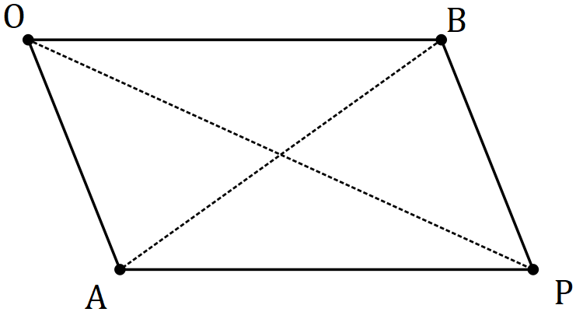

Use a vector method to prove that the sum of the squares of the lengths of the diagonals of a parallelogram is equal to the sum of the squares of the lengths of the sides.

|  |
| --- |
| **Solution** |
|  |
| **Specific behaviours** |
| ✓ expresses and in terms of $a$ and $b$ ✓ uses scalar product to expand sums and differences  ✓ simplifies scalar products as magnitudes  ✓ expresses in terms of sides  ✓ logical presentation of proof |

Question 8 (8 marks)

(a) Determine all complex solutions to the equation $z^{2}-2z+5=0$. (3 marks)

|  |
| --- |
| **Solution** |
| $${\left(z-1\right)}^{2}-1=-5$$ $${\left(z-1\right)}^{2}=4i^{2} \\ z-1=±2i$$ $$z=1+2i, z=1-2i$$ |
| **Specific behaviours** |
| ✓ completes square  ✓ simplifies square roots of both sides  ✓ states both solutions |

(b) Determine the values of the **positive** real constants $p$ and $q$ so that $p-2i$ is a solution to the equation $2z^{2}-qz+26=0$. (5 marks)

|  |
| --- |
| **Solution** |
| $$2{\left(p-2i\right)}^{2}-q\left(p-2i\right)+26=0 \\ 2\left(p^{2}-4pi-4\right)-pq+2qi+26=0$$ $$2p^{2}-8pi-8-pq+2qi+26=0 \\ 2p^{2}-pq+18+\left(2q-8p\right)i=0$$ $$\operatorname{Im}{:} 2q-8p=0⇒q=4p$$ $$\operatorname{Re}{:} 2p^{2}-4p^{2}+18=0⇒p^{2}=9$$ $$p>0⇒p=3, q=12$$ |
| **Specific behaviours** |
| ✓ substitutes, expanding square  ✓ fully expands and simplifies  ✓ uses imaginary terms to express $q$ in terms of $p$ ✓ uses real terms to determine $p^{2}$ ✓ states values |

Supplementary page

Question number: _________

© 2018 WA Exam Papers. Carmel School has a non-exclusive licence to copy and communicate this document for non-commercial, educational use within the school. No other copying, communication or use is permitted without the express written permission of WA Exam Papers. SN014-121-2.